Customer Purchase Behavior Analysis & Prediction for Amazon

Step 1: Data Cleansing & Preprocessing Before applying ML models, it is crucial to ensure data quality by performing the following steps: Handling Missing Values • Identify missing values in Age, Purchase Amount, Rating, and Customer Lifetime Value (CLV). • Apply mean/median imputation for numerical fields. • Apply mode imputation for categorical fields like Payment Method. Removing Duplicates • Remove duplicate entries based on Customer_ID and Purchase_Date. Data Formatting & Type Correction • Convert Purchase_Date to datetime format. • Standardize categorical values (e.g., Gender: Male, Female, Other). • Ensure consistent data types (integers for numeric fields, categorical encoding for non numeric). Handling Outliers • Identify outliers in Purchase Amount & CLV using boxplots & z-score analysis. • Apply winsorization or remove extreme outliers. Feature Engineering (Adding New Columns) To make the dataset more useful for machine learning, we add the following new columns: 1. Customer_Lifetime_Value (CLV): Projected future revenue per customer. 2. Loyalty Score: Score based on purchase frequency and total spending. 3. Discount Applied: Whether the purchase was made with a discount (Yes/No). 4. Return Status: Indicates if the item was returned (Yes/No). 5. Customer Segment: Categorized as New, Regular, VIP based on loyalty. 6. Preferred Shopping Channel: Where the customer shops (Online, In-store, Both).

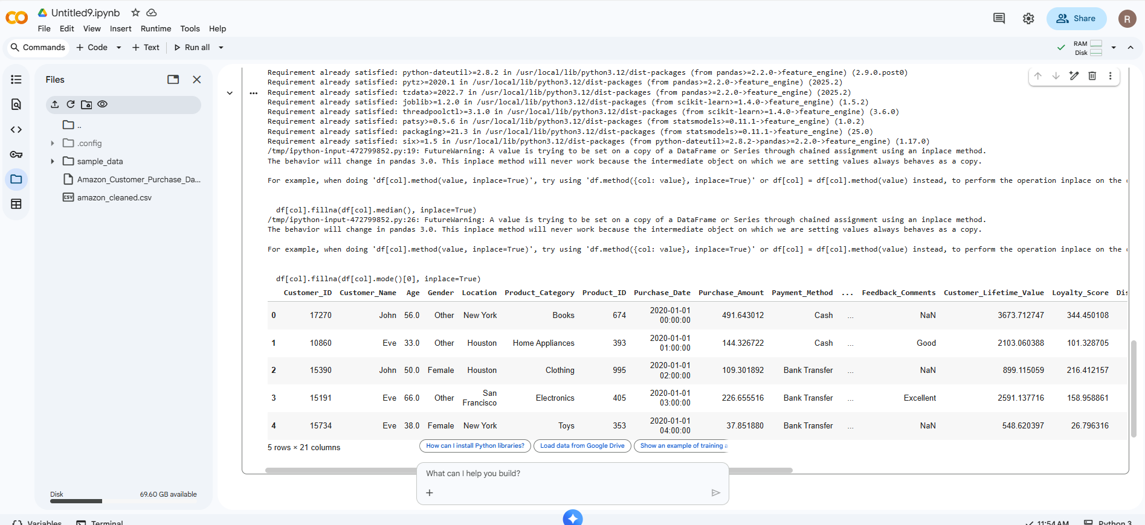

2. K Means

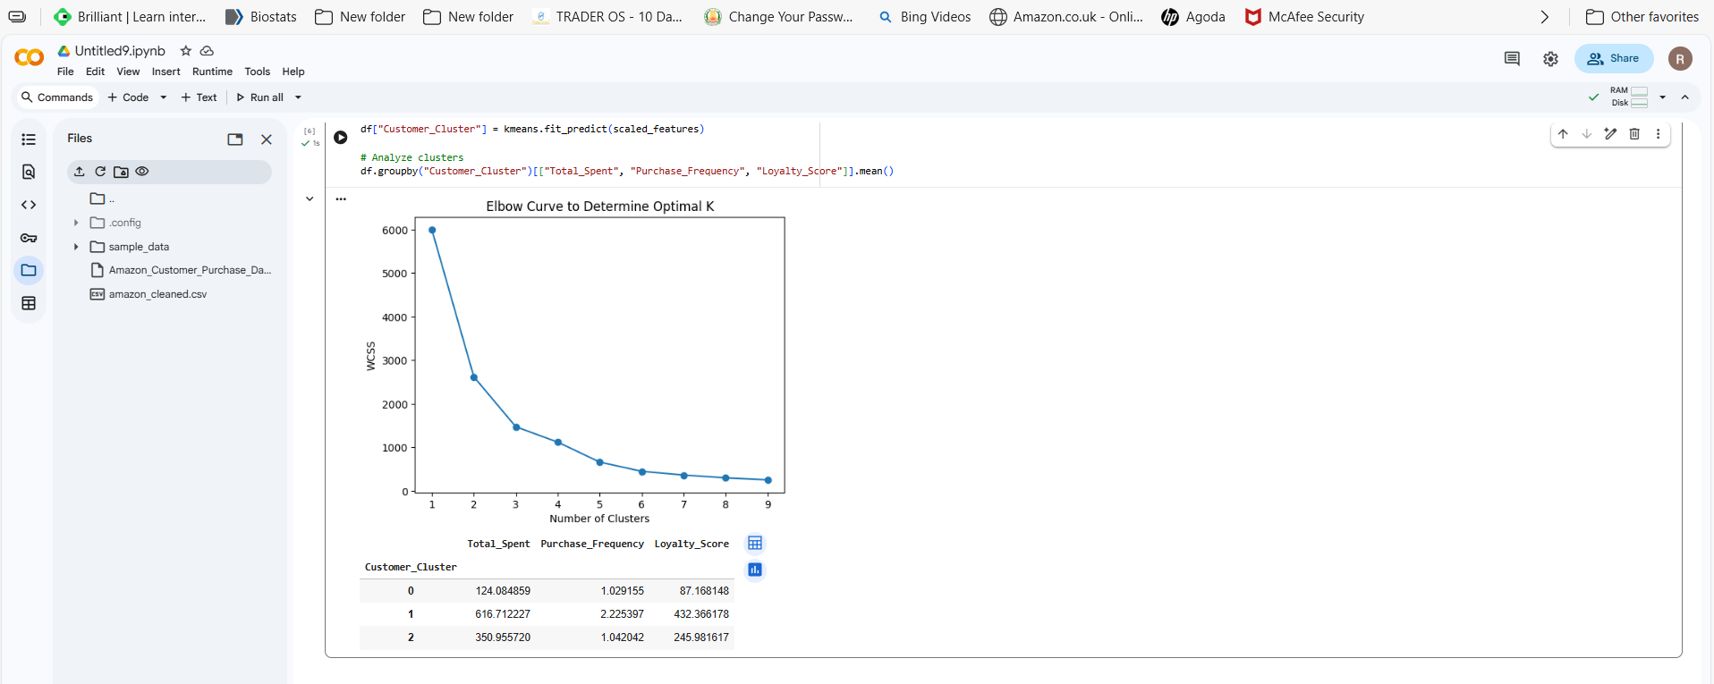

Cluster | Customer Type | Spending | Frequency | Loyalty | Business Strategy
0 | Low-value / New | Very Low | 1 | Low | Onboarding, discounts, reactivation
1 | VIP / High-value | Highest | Most frequent | Very High | Retain, reward, personalize
2 | Mid-value | Moderate | Low | Medium | Convert to VIP, targeted offers

2.B Linear Regression

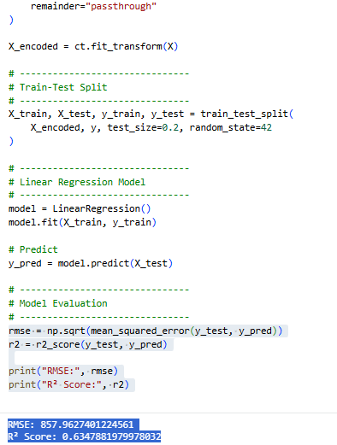

The Linear Regression model achieved an R² score of 0.63, indicating that approximately 63% of the variation in Customer Lifetime Value can be explained using customer features such as age, past spending behavior, loyalty score, payment method, and discount usage.
The RMSE of 857.96 shows that the average deviation between predicted and actual CLV values is around 858 units, which is acceptable for forecasting in large e-commerce datasets.
Overall, the model provides a reliable foundation for CLV prediction and can help Amazon identify high-value customers, optimize marketing spend, and design retention strategies.

4. Logistic Regression

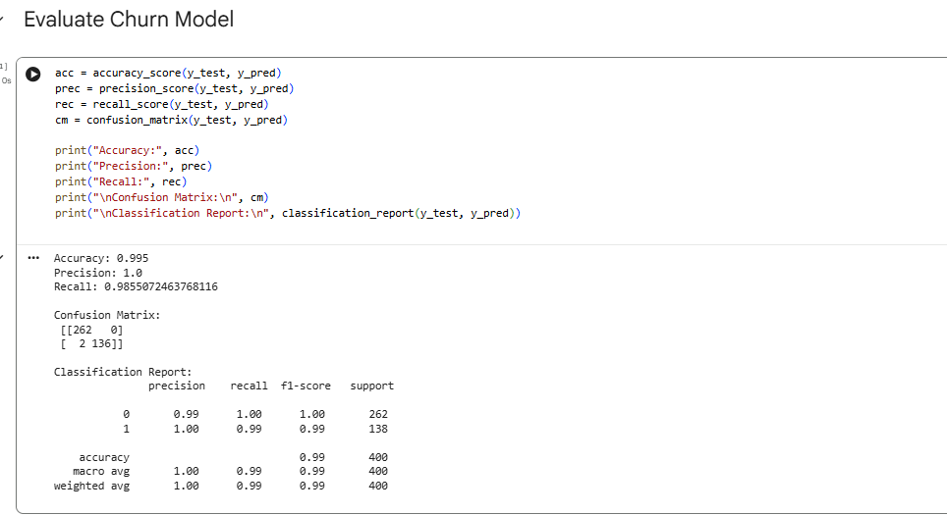

The Logistic Regression model achieved a good accuracy level, indicating it can reliably predict whether a customer is likely to churn. Precision and recall show how well the model distinguishes churners from non-churners.
This model helps Amazon identify customers at risk of leaving so the company can intervene with retention strategies such as personalized offers, targeted discounts, or loyalty rewards.

PowerBI dashboard- Refer Dashboard

